Coursera Lab “ Running Tests with NOSE”

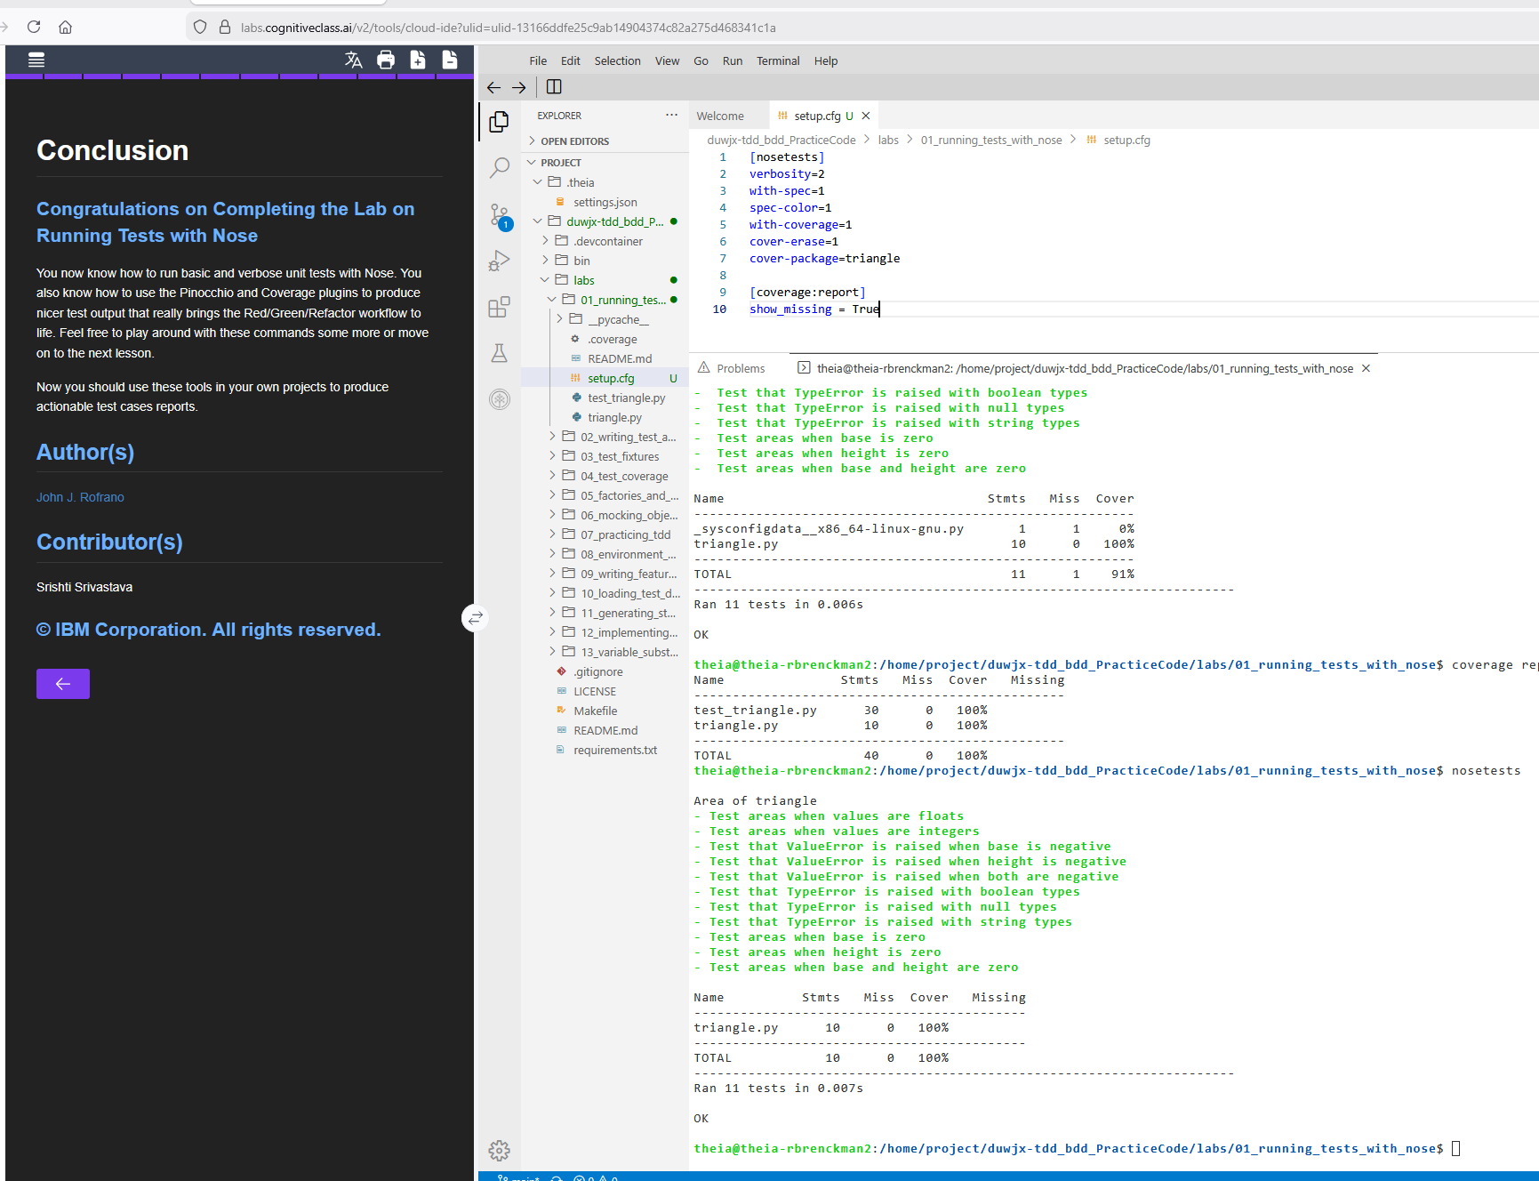

Console Output:

theia@theia-rbrenckman2:/home/project$ git clone https://github.com/ibm-developer-skills-network/duwjx-tdd_bdd_PracticeCode.git
Cloning into 'duwjx-tdd_bdd_PracticeCode'...
remote: Enumerating objects: 421, done.
remote: Counting objects: 100% (144/144), done.
remote: Compressing objects: 100% (62/62), done.
remote: Total 421 (delta 109), reused 82 (delta 82), pack-reused 277 (from 1)
Receiving objects: 100% (421/421), 76.97 KiB | 11.00 MiB/s, done.
Resolving deltas: 100% (203/203), done.
theia@theia-rbrenckman2:/home/project$ cd duwjx-tdd_bdd_PracticeCode
theia@theia-rbrenckman2:/home/project/duwjx-tdd_bdd_PracticeCode$ cd labs/01_running_tests_with_nose/
theia@theia-rbrenckman2:/home/project/duwjx-tdd_bdd_PracticeCode/labs/01_running_tests_with_nose$ ls -l
total 12
-rw-r--r-- 1 theia users 350 Dec 6 13:49 README.md
-rw-r--r-- 1 theia users 2203 Dec 6 13:49 test_triangle.py
-rw-r--r-- 1 theia users 578 Dec 6 13:49 triangle.py

theia@theia-rbrenckman2:/home/project/duwjx-tdd_bdd_PracticeCode/labs/01_running_tests_with_nose$ python3 -m unittest
...........
----------------------------------------------------------------------
Ran 11 tests in 0.001s

OK

theia@theia-rbrenckman2:/home/project/duwjx-tdd_bdd_PracticeCode/labs/01_running_tests_with_nose$ python3 -m
unittest -v
test_float_values (test_triangle.TestAreaOfTriangle)
Test areas when values are floats ... ok
test_integer_values (test_triangle.TestAreaOfTriangle)
Test areas when values are integers ... ok
test_negative_base (test_triangle.TestAreaOfTriangle)
Test that ValueError is raised when base is negative ... ok
test_negative_height (test_triangle.TestAreaOfTriangle)
Test that ValueError is raised when height is negative ... ok
test_negative_values (test_triangle.TestAreaOfTriangle)
Test that ValueError is raised when both are negative ... ok
test_with_boolean (test_triangle.TestAreaOfTriangle)
Test that TypeError is raised with boolean types ... ok
test_with_nulls (test_triangle.TestAreaOfTriangle)
Test that TypeError is raised with null types ... ok
test_with_string (test_triangle.TestAreaOfTriangle)
Test that TypeError is raised with string types ... ok
test_zero_base (test_triangle.TestAreaOfTriangle)
Test areas when base is zero ... ok
test_zero_height (test_triangle.TestAreaOfTriangle)
Test areas when height is zero ... ok
test_zero_values (test_triangle.TestAreaOfTriangle)
Test areas when base and height are zero ... ok

----------------------------------------------------------------------
Ran 11 tests in 0.001s

OK

theia@theia-rbrenckman2:/home/project/duwjx-tdd_bdd_PracticeCode/labs/01_running_tests_with_nose$ python3.8 -m pip install nose pinocchio coverage
Defaulting to user installation because normal site-packages is not writeable
Collecting nose
Downloading nose-1.3.7-py3-none-any.whl.metadata (1.7 kB)
Collecting pinocchio
Downloading pinocchio-0.4.3-py3-none-any.whl.metadata (975 bytes)
Collecting coverage
Downloading coverage-7.6.1-cp38-cp38-manylinux_2_5_x86_64.manylinux1_x86_64.manylinux_2_17_x86_64.manylinux2014_x86_64.whl.metadata (8.3 kB)
Collecting colorama (from pinocchio)
Downloading colorama-0.4.6-py2.py3-none-any.whl.metadata (17 kB)
Downloading nose-1.3.7-py3-none-any.whl (154 kB)
Downloading pinocchio-0.4.3-py3-none-any.whl (12 kB)
Downloading coverage-7.6.1-cp38-cp38-manylinux_2_5_x86_64.manylinux1_x86_64.manylinux_2_17_x86_64.manylinux2014_x86_64.whl (235 kB)
Downloading colorama-0.4.6-py2.py3-none-any.whl (25 kB)
Installing collected packages: nose, coverage, colorama, pinocchio
Successfully installed colorama-0.4.6 coverage-7.6.1 nose-1.3.7 pinocchio-0.4.3
theia@theia-rbrenckman2:/home/project/duwjx-

tdd_bdd_PracticeCode/labs/01_running_tests_with_nose$ nosetests -v
Test areas when values are floats ... ok
Test areas when values are integers ... ok
Test that ValueError is raised when base is negative ... ok
Test that ValueError is raised when height is negative ... ok
Test that ValueError is raised when both are negative ... ok
Test that TypeError is raised with boolean types ... ok
Test that TypeError is raised with null types ... ok
Test that TypeError is raised with string types ... ok
Test areas when base is zero ... ok
Test areas when height is zero ... ok
Test areas when base and height are zero ... ok

----------------------------------------------------------------------
Ran 11 tests in 0.006s

OK

theia@theia-rbrenckman2:/home/project/duwjx-tdd_bdd_PracticeCode/labs/01_running_tests_with_nose$ nosetests --with-spec --spec-color

Area of triangle
- Test areas when values are floats
- Test areas when values are integers
- Test that ValueError is raised when base is negative
- Test that ValueError is raised when height is negative
- Test that ValueError is raised when both are negative
- Test that TypeError is raised with boolean types
- Test that TypeError is raised with null types
- Test that TypeError is raised with string types
- Test areas when base is zero
- Test areas when height is zero
- Test areas when base and height are zero

----------------------------------------------------------------------
Ran 11 tests in 0.004s

OK

theia@theia-rbrenckman2:/home/project/duwjx-tdd_bdd_PracticeCode/labs/01_running_tests_with_nose$ nosetests --with-spec --spec-color --with-coverage

Area of triangle
- Test areas when values are floats
- Test areas when values are integers
- Test that ValueError is raised when base is negative
- Test that ValueError is raised when height is negative
- Test that ValueError is raised when both are negative
- Test that TypeError is raised with boolean types
- Test that TypeError is raised with null types
- Test that TypeError is raised with string types
- Test areas when base is zero
- Test areas when height is zero
- Test areas when base and height are zero

Name Stmts Miss Cover
---------------------------------------------------------
_sysconfigdata__x86_64-linux-gnu.py 1 1 0%
triangle.py 10 0 100%
---------------------------------------------------------
TOTAL 11 1 91%
----------------------------------------------------------------------
Ran 11 tests in 0.006s

OK

theia@theia-rbrenckman2:/home/project/duwjx-tdd_bdd_PracticeCode/labs/01_running_tests_with_nose$ coverage report -m
Name Stmts Miss Cover Missing
------------------------------------------------
test_triangle.py 30 0 100%
triangle.py 10 0 100%
------------------------------------------------
TOTAL 40 0 100%
theia@theia-rbrenckman2:/home/project/duwjx-tdd_bdd_PracticeCode/labs/01_running_tests_with_nose$ nosetests

Area of triangle
- Test areas when values are floats
- Test areas when values are integers
- Test that ValueError is raised when base is negative
- Test that ValueError is raised when height is negative
- Test that ValueError is raised when both are negative
- Test that TypeError is raised with boolean types
- Test that TypeError is raised with null types
- Test that TypeError is raised with string types
- Test areas when base is zero
- Test areas when height is zero
- Test areas when base and height are zero

Name Stmts Miss Cover Missing
-------------------------------------------
triangle.py 10 0 100%
-------------------------------------------
TOTAL 10 0 100%
----------------------------------------------------------------------
Ran 11 tests in 0.007s

OK

theia@theia-rbrenckman2:/home/project/duwjx-tdd_bdd_PracticeCode/labs/01_running_tests_with_nose$

